Lab Assignment 5

Write an assembly language program to perform division of 8-bit data.

org 100h

; Initialize values

mov al,96h ; Move 89h (137 in decimal) into AL

mov bl,10h ; Move 10h (16 in decimal) into BL

; Perform division (AL / BL)

idiv bl ; AL = quotient, AH = remainder

mov bl,al ; Store quotient in BL

mov bh,ah ; Store remainder in BH

; Convert first digit (quotient) to ASCII

and al,0f0h ; Mask higher nibble of AL

shr al,4 ; Shift right 4 bits to get the first hex digit

add al,30h ; Convert to ASCII (0-9)

cmp al,39h ; Check if it's a number or letter (0-9)

jle print_first_digit1

add al,7 ; Convert to ASCII (A-F)

print_first_digit1:

mov dl,al ; Move the result to DL (for printing)

mov ah,02h ; Print function

int 21h ; Interrupt to print the character

; Convert second digit (quotient) to ASCII

mov al,bl ; Move the quotient back into AL

and al,0fh ; Mask the lower nibble of AL

add al,30h ; Convert to ASCII (0-9)

cmp al,39h ; Check if it's a number or letter (0-9)

jle print_second_digit1

add al,7 ; Convert to ASCII (A-F)

print_second_digit1:

mov dl,al ; Move the result to DL (for printing)

mov ah,02h ; Print function

int 21h ; Interrupt to print the character

; Print remainder (remainder is in BH)

; Convert first digit (upper nibble of remainder) to ASCII

mov al,bh ; Move remainder into AL

and al,0f0h ; Mask the higher nibble

shr al,4 ; Shift right 4 bits to get the first hex digit

add al,30h ; Convert to ASCII (0-9)

cmp al,39h ; Check if it's a number or letter (0-9)

jle print_first_rem_digit

add al,7 ; Convert to ASCII (A-F)

print_first_rem_digit:

mov dl,al ; Move the result to DL (for printing)

mov ah,02h ; Print function

int 21h ; Interrupt to print the character

; Convert second digit (lower nibble of remainder) to ASCII

mov al,bh ; Move remainder back into AL

and al,0fh ; Mask the lower nibble

add al,30h ; Convert to ASCII (0-9)

cmp al,39h ; Check if it's a number or letter (0-9)

jle print_second_rem_digit

add al,7 ; Convert to ASCII (A-F)

print_second_rem_digit:

mov dl,al ; Move the result to DL (for printing)

mov ah,02h ; Print function

int 21h ; Interrupt to print the character

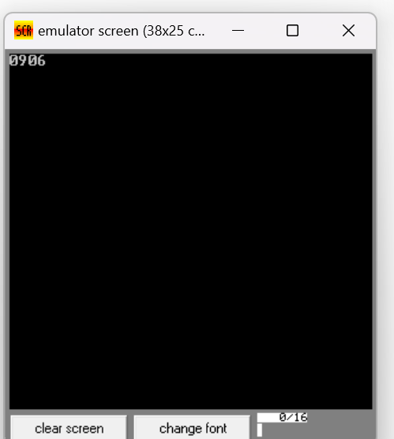

Write a program in assembly language to perform division of 16-bit data.

org 100h

mov ax,1780h

mov bx,1000h

div bx

mov bx,ax

mov cx,dx

mov ah,ch

and ah,0f0h

shr ah,4

add ah,30h

cmp ah,39h

jle print_high_nibble32

add ah,7

print_high_nibble32:

mov dl,ah

mov ah,02h

int 21h

mov ah,ch

and ah,0fh

add ah,30h

cmp ah,39h

jle print_low_nibble32

add ah,7

print_low_nibble32:

mov dl,ah

mov ah,02h

int 21h

mov ah,cl

and ah,0f0h

shr ah,4

add ah,30h

cmp ah,39h

jle print_low_nibble24

add ah,7

print_low_nibble24:

mov dl,ah

mov ah,02h

int 21h

mov ah,cl

and ah,0fh

add ah,30h

cmp ah,39h

jle print_high_nibble24:

add ah,7

print_high_nibble24:

mov dl,ah

mov ah,02h

int 21h

mov ah, bh

shr ah, 4

add ah, 30h

cmp ah, 39h

jle print_high_nibble

add ah, 7

print_high_nibble:

mov dl, ah

mov ah, 02h

int 21h

mov ah, bh

and ah, 0fh

add ah, 30h

cmp ah, 39h

jle print_low_nibble

add ah, 7

print_low_nibble:

mov dl, ah

mov ah, 02h

int 21h

mov ah, bl

shr ah, 4

add ah, 30h

cmp ah, 39h

jle print_high_nibble2

add ah, 7

print_high_nibble2:

mov dl, ah

mov ah, 02h

int 21h

mov ah, bl

and ah, 0fh

add ah, 30h

cmp ah, 39h

jle print_low_nibble2

add ah, 7

print_low_nibble2:

mov dl, ah

mov ah, 02h

int 21h

mov ah,4ch

 int 21h

